Multiple-choice section – choose the correct answer

Question 1 [8.2]

In an isosceles triangle, the angle between two sides of equal length is 86°. The size of another angle in the triangle is:

A 47° B 94° C 86° D 4°

Question 2 [8.2]

Find the value of the pronumeral.

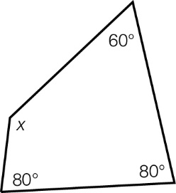

A 220° B 80° C 60° D 140°

Question 3 [8.2]

An exterior angle of a triangle is 111°. The two opposite interior angles are *a* and 53°. The value of *a* is:

A 16° B 53° C 58° D 196°

Question 4 [8.2]

The size of angle SQP is 40°. If the line QT bisects angle SQR, what is the size of angle TQR?

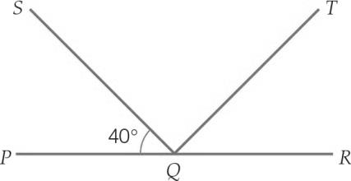

A 140° B 70° C 40° D 80°

Question 5 [8.1]

A transversal line is a line that:

A is perpendicular to another line

B is parallel to another line

C intersects two or more lines

D bisects another line.

Question 6 [8.4]

When two triangles have two angles the same and one pair of sides equal in length in corresponding positions, then the two triangles are congruent because of:

A ASA B SAA C AAA D SSS

Question 7 [8.5]

In a kite, an angle between two sides of different lengths is 94°. Another angle in the kite must be:

A 266° B 94° C 133° D 96°

Question 8 [8.5]

In the rhombus below, ∠*SPO* = 52° and ∠*QPO* = 55°. What is the size of ∠*QRS*?

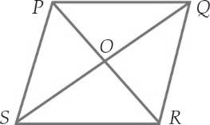

A 52° B 73° C 55° D 107°

Multiple-choice results: ___ /8

Short answer section

Question 9 2 marks [8.3, 8.5]

Choose the correct word from the following list to fill each of the gaps in the following sentences.

*triangles square rectangle translation reflection rotation*

(a) A quadrilateral can be divided into two ________________ with a diagonal line.

(b) Another name for a slide is a ________________.

Question 10 2 marks [8.3]

Using an example, explain the meaning of the term congruent.

Question 11 2 marks [8.1]

State if each of the following pairs of angles are complementary or supplementary.

(a) 67° and 23° ________________

(b) 5° and 175° ________________

Question 12 4 marks [8.1]

Find the value of the pronumeral in each diagram. Give reasons for your answer.

(a)

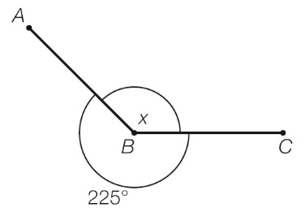

(b)

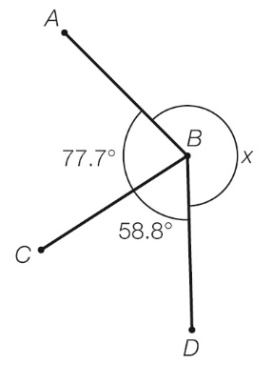

Question 13 2 marks [8.4]

The figure below is a parallelogram. Name any two pairs of congruent triangles.

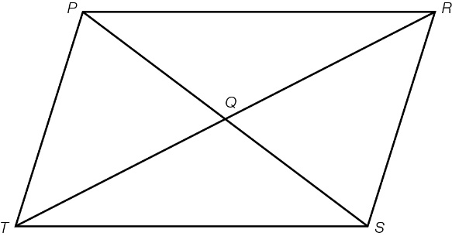

Question 14 6 marks [8.1]

Find the value of the angles *a*, *b* and *c* in the following diagram. Give a reason for each answer.

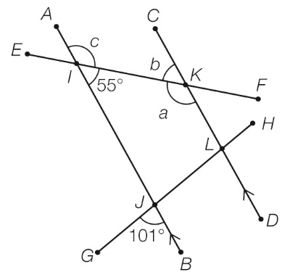

Question 15 3 marks [8.1]

*a* and *b* are supplementary angles. If *a* is 40° larger than *b*, what is the size of each angle?

Question 16 4 marks [8.2]

Find the value of the pronumerals in the following diagram, giving a reason for each answer.

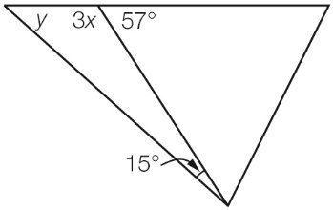

Question 17 2 marks [8.2]

Find the value of the pronumeral *x*.

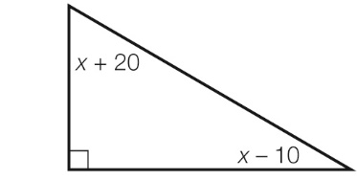

Question 18 6 marks [8.2]

Find the value of each pronumeral, giving a reason for each answer.

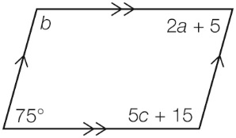

Question 19 4 marks [8.2]

(a) What is the interior angle sum of a regular octagon?

(b) What is the size of each angle in a regular pentagon?

Question 20 3 marks [8.2]

Find the value of the angle *Q,* giving reasons for your answer.

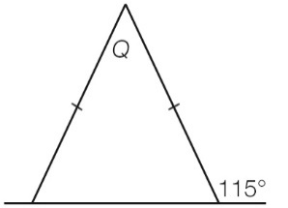

Question 21 8 marks [8.3]

(a) Using the grid below, plot the points *A*(-5, 7), *B*(-7, 5), *C*(-6, 1) and *D*(-4, 4). Join the points to form a quadrilateral *ABCD* and label the points.

(b) Perform the translation of [6, -4] on *ABCD*.

(c) Using the shape you created in (b), perform a clockwise rotation of 90° about the point *C*′.

(d) Using the shape you created in (c), perform a reflection in the *y*-axis. What are the coordinates of this transformed quadrilateral?

*A*′′′ ____________ *B*′′′ ____________ *C*′′′ ____________ *D*′′′ ____________

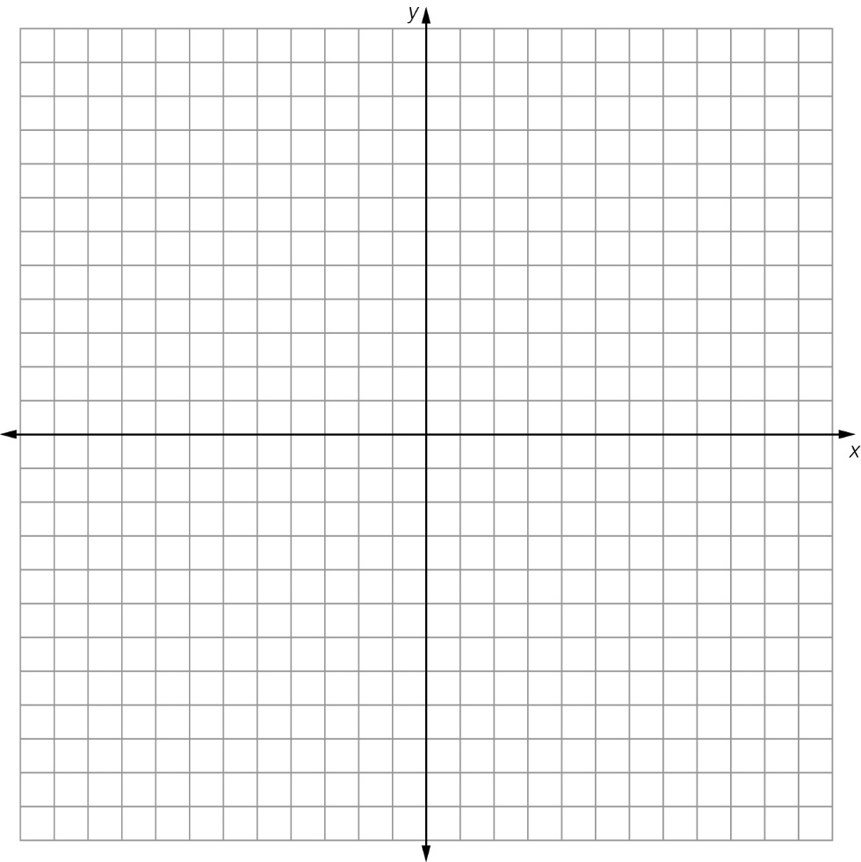

Question 22 2 marks [8.3]

The following two quadrilaterals are congruent. Use your knowledge of matching angles and side lengths to find the value of the pronumerals *x* and *y*.

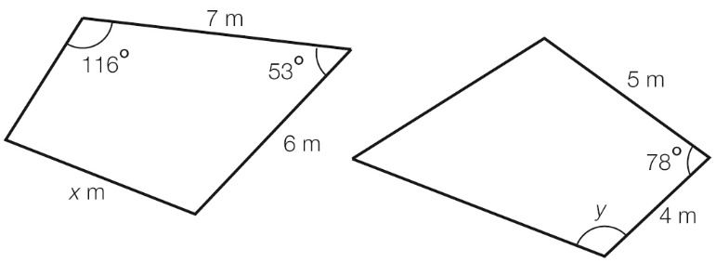

Question 23 3 marks [8.4]

∆*ABC* is congruent to ∆*PRS*. In ∆*PQS*, *R* is the midpoint of *QS*.

Prove that ∆*PQR* is congruent to ∆*ABC*.

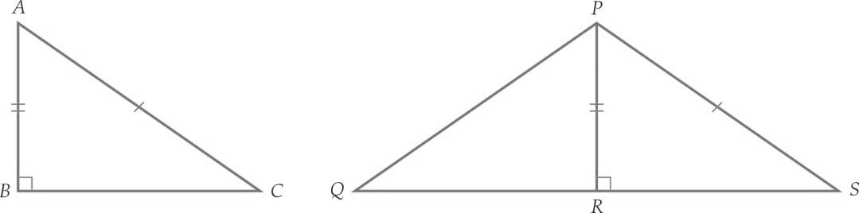

Question 24 3 marks [8.4]

For the following pair of triangles:

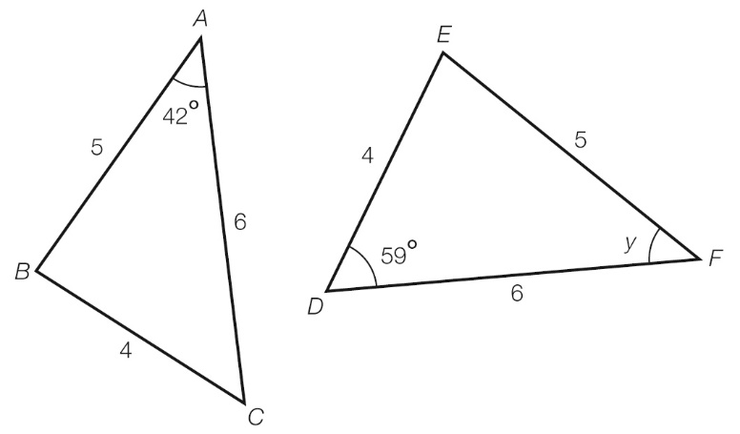

(a) show that they are congruent

(b) find the value of the angle *y*.

Question 25 2 marks [8.5]

Use congruent triangles and known angle facts to find the value of the angle *x* in the quadrilateral. Give reasons for your answer.

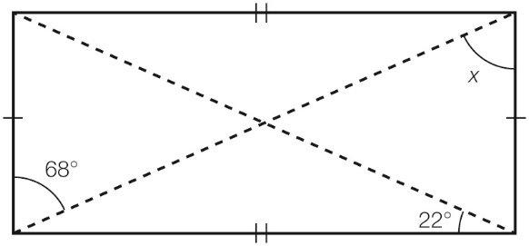

Short answer results: ___ / 58

Extended answer section

Question 26 3 marks [8.5]

In rectangle *WXYZ*, diagonals *WY* and *XZ* intersect at *V*.

If the length of *XZ* = 50 cm and the length of *VY* = *x* + 8, find the value of *x.*

Question 27 5 marks [8.2]

(a) Find the value of the angles *a*, *b* and *c* in the quadrilateral. Give reasons for your answer.

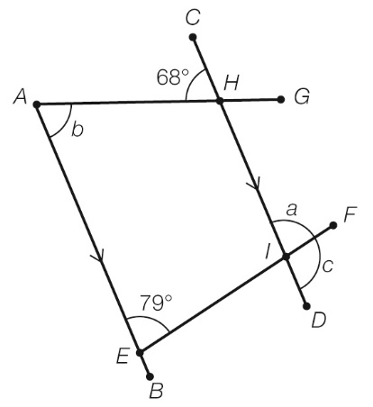

(b) What other angle(s) are equal to ∠*FID* (or *c*)?

(c) What is the size of ∠*AHI*?

Question 28 5 marks [8.2]

Find the value of all the pronumerals, giving reasons for your answers.

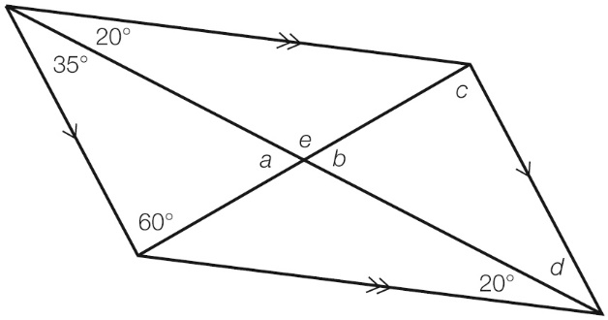

Extended answer results: ___ / 13

TOTAL test results: ___ / 79